# Something old, something borrowed, something new

## Level introduction

### Level story

Upon hearing of Robert's death prophecy, Minerva and Helena ventured into the Forbidden Forest to seek information from a Centaur/Elf. This prompted him to retrieve "the book of no more", an ancient book of prophecies kept in the restricted area of ​​the Hogwarts library. In this level, Minerva will need to enter the restricted area of ​​the Hogwarts library and retrieve the book. However, the library itself will try in every way to ward off unwanted intruders.

### Library Structure

The library develops on two floors. The entrance of the library is on the first floor and leads directly into the main section. On the short side of the main section, opposed to the entrance, there’s the door for the restricted section. Two stairs, one for each long side of the room, leads to the balcony, from where the player can access the remaining five sections: the spell book section and the astronomy section, on the long side on the left, looking from the entrance; the botany section and the bestiary section, on the long side on the right; the legal section, on the same short side as the entrance.

### Area description

Hogwarts library is one of the biggest in all Great Britain, containing tens of thousands of books. Its numerous sections are filled with shelves, tables, desks and, of course, mysteries and secret passages. During the day, students go there to study and to borrow books for their research assignments. Only one of the many sections of the library has restricted access. This area is called Restricted section.

By night, students are not allowed in the library, as well as in any other part of the castle. Of course, the library isn’t like any other part of the castle. As soon as Hogwarts curfew starts, the powerful and weird magic contained in the books come to life, guarding the library from intruders. Of all the sections, the restricted one is especially protected. The door behind which the section is located is closed. To open it, four signets must be presented. These four signets are shaped like golden doubloons and they are distributed in as many sections of the library: the spell book section, the botany section, the bestiary section and the astronomy section.

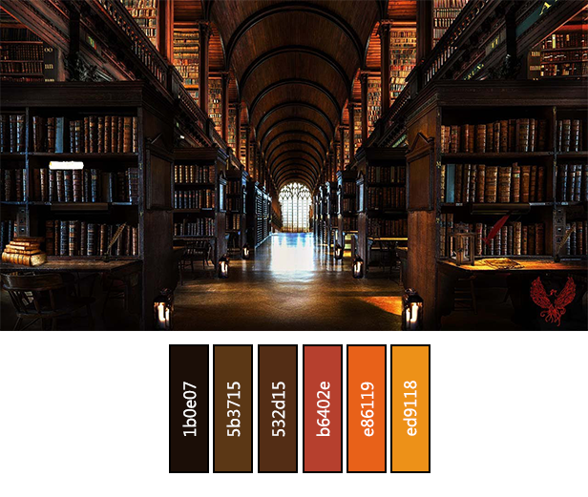

### NPCs introduction

The same corridors and halls that the students walk during the day are wandered by spirits and spectres at night time. Most of them, as well as the rest of the library, don’t enjoy intruders and tends to ignore them. That’s not always true. Some of the ghosts can interact with Minerva and even ask her for particular tasks (subquests). (Onorius Durandall into ? ...)

#### Louis Delacroix

Louis Delacroix was one the most renowned French poet of the wizard world. He lived in the sixteenth century and wrote very successful collections of poems such as “two hearts and a broomstick” and “love, death and polyjuice”. Despite being famous and rich, he was always a mama’s boy. He often attended gallant events dressed in his finest outfit and wearing the colorful woolen socks his mother made for him. The strong hit to the head he took from a falling lamp when he died visiting Hogwarts library has made his ghost quite forgetful. Now he wanders in the library, looking for his mother’s amulet and losing it a few minutes later. + img

#### Barnabs Van Weber

Barnabs Van Weber was a german judge. He grew up in Great Britain and became part of the Wizengamot at a very young age. In 1490 he aided Hogwarts when the Sorting Hat was falsely accused of accepting jellies as bribes, and has been one of the school’s legal advisor until his death. He spends most of his time as a ghost in the legal section, arguing with the books. Every dispute ends with the books making fun of him for his very long nose. + img

#### Onorius Durandall

#### Ever heard of the expression “book worm”? Onorius Durandall was the bookiest worm the wizarding world has ever seen. It was Rowena Ravenclaw’s idea to make him the first guardian of the library, soon after Hogwarts foundation. Part of the library actual greatness is due to Onorius incredible commitment in retrieving and restoring every sort of magical book, even the ones whose existence was barely rumored. The library became his life. He spent most of his time in it, both guarding and reading the books he was so binded to. This made him a very powerful and knowledgeable wizard, too. Many years later, when Hogwarts collection became big enough to contain books that were not exactly suited for a school, Onorius came up with the idea of the restricted section. He eventually became obsessed by it, to the point where he stopped leaving the library at all, just to be sure no one entered the section. One morning, on the verge of his 98th birthday, the students found Onorius lying in the cot he built in the library, dead. At the entrance of the restricted section not his body, but his ghost, was guarding it, and he still does to this day.

### Goals of the level

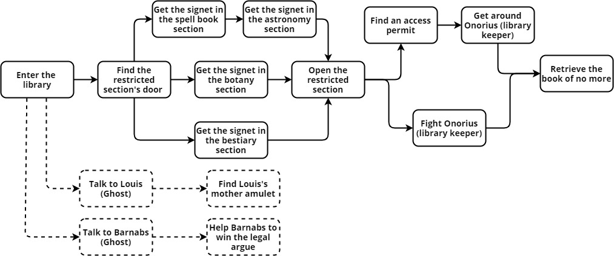Minerva must enter the restricted area of ​​the Hogwarts library to retrieve "the book of no more". To reach this area she must open a door with four keys (signet) hidden in the various rooms of the library. Each room is protected by a spell. Once the passage opens, Minerva will have to face Onorius Durandal, the ghost library keeper. She can decide to fight him or to get around him by taking an access permit in the Legal section of the library. The library consists of 6 main areas: Main section, Spell books section, Astronomy section, Botany section, Bestiary section, Legal Section and Restricted section. There are two NPCs in the level. Louis Delacroix is a ghost who will ask Minerva to find the amulet of his mother. Barnabs Van Weber is a ghost who will ask Minerva some assistance for winning a verbal fight with other ghosts.

### Gameplay introduction

The level includes combat, puzzle, platform and stealth game modes as well as the ability to freely explore the library, discover the mysteries it hides and talk to the ghosts that inhabit it. Furthermore, as already specified, the level is divided into sub-areas which have different goals, different types of gameplay and so on.

#### Exploration mode:

The level is mainly based on the exploration of the game map. The main objective proposed to the player is to find the four seals to open the passage to the restricted section. So much of the level gameplay will be exploring the various rooms, finding a way to access them and retrieve the seals.

#### Dialogue mode:

In the level there is a dialogic component, albeit limited. In the main section there are two NPCs which it is possible to talk with. These characters can give you information about the location of certain objects, they can tell you about their history and the history of the library. In the restricted section Onorius Durandall, the keeper of the library, will question Minerva to understand the reason for her presence. Through the dialogues the player can choose whether to fight or find an alternative to get around him.

#### Combat mode:

In almost all the rooms of the library there are fights with enemies of different dangers. Often the fights are combined with a puzzle component. In the spell book section Minerva must light all the candles in the room to injure the enemy. In this way, the combat alternates between the puzzle phase and the combat phase.

#### Puzzle mode:

As already explained in the combat mode paragraph, the puzzles are combined with the fights in order to provide two different types of challenges. Nevertheless, as there are fights without puzzles, there are isolated puzzles in the various sub-areas of the library.

#### Platform mode:

The level has two zones that Minerva must use the animagus spell to get through. In particular, these areas are the secret passage to the bestiary section and the passage along the ceiling of the library to reach the astronomy section. Also inside the astronomy section there are platform areas.

#### Stealth mode:

After recovering two of the four seals, in the main section the books will animate to identify the intruder. Minerva can avoid ghost-book fights by not being detected. This entails another game mode: stealth mode.

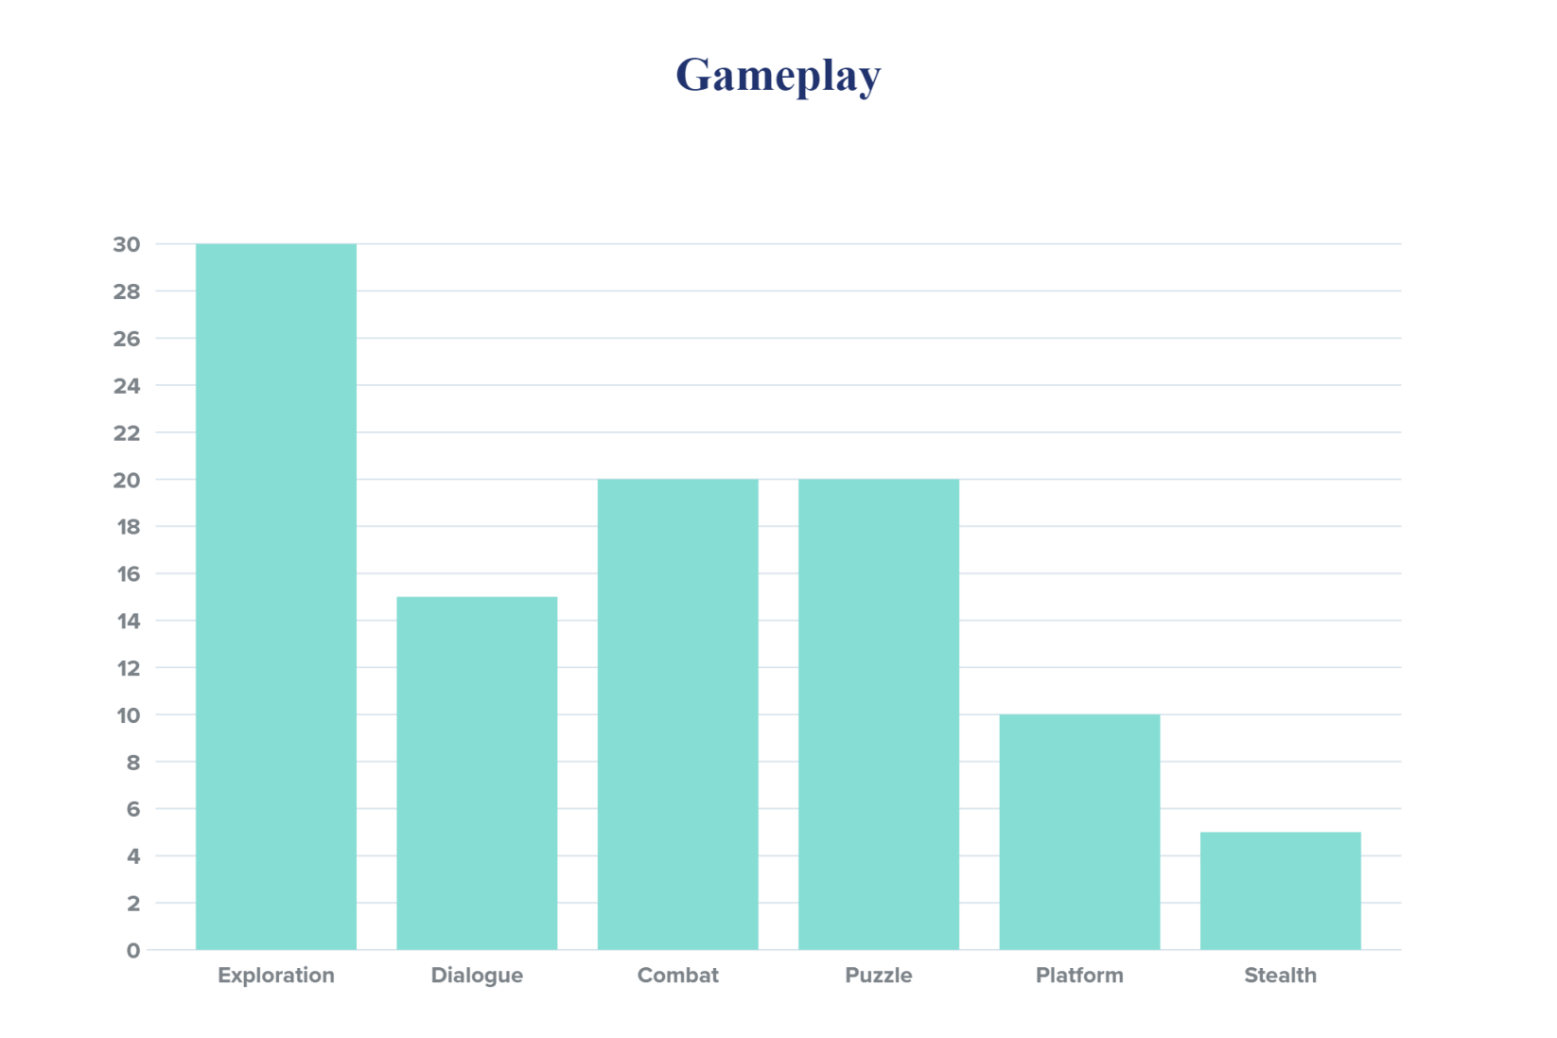

https://spark.adobe.com/express-apps/chart/?authredirect=true#

### Map

The level map includes the Hogwarts library with its subsections. We made the blueprint starting from a conceptual diagram. In this way, each space within the game reflects a particular functionality within the level.

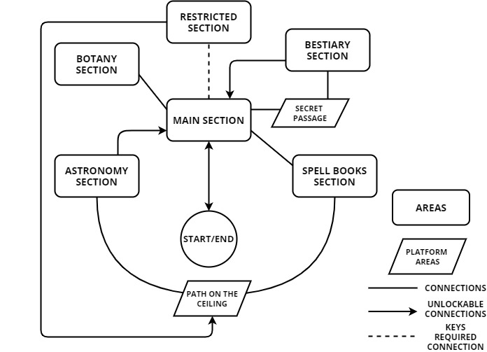

From the diagram you can clearly see that a room, the main section is located in the center of the map and has the function of connecting all the other rooms including the restricted section. The restricted section, on the other hand, is the final destination of the level. It can only be unlocked after exploring all the other rooms. Spell book section, botany section, astronomy section and bestiary section are the rooms they contain the signets for entering the restricted section. each of these has a particular different "puzzle" to solve. We have decided to add a room to this diagram, the legal section, so that we can articulate the challenge with the final boss (Onorius Durandall) in two different ways: defeat him in combat, or get around him by a permission found in the legal section. finally we wanted to specify two intermediate steps between some rooms because they represent the main platform parts of the level.

### Paths

#### C:\Users\689290\Downloads\mapdgm (1).jpg

#### Red path:

From the main section you can directly access the spell book section. Once the enemy in this room is defeated, Minerva can locate a path that will lead her over the ceiling beams. This path leads to the astronomy section. Once this room is complete, Minerva can open the door that overlooks the main section.

#### Blue path:

In the main section, the door of the bestiary section is closed. Minerva must find an alternate passage to access it. Under the gallery, in correspondence with the door, there is a bookcase which, unlike the others, can be moved. Behind the library there is a secret passage, accessible only after the transformation into a cat that leads directly to the bestiary section.

#### Green path:

The botany section can be accessed directly from the front door. This room has no particular connections with the others. This path is not as simple as it seems due to the challenge in the botany section. In fact, once she has collected the seal, Minerva will have to manage to escape from the room while it tries to trap her.

#### Yellow path:

Once inside the restricted section, Minerva will have to go back by an alternative route. Inside the room there are various connections that lead to the top of the library roof. Thanks to this passage Minerva, transformed into a cat, can reach the path of the ceiling beams and return to the main section via the spell book section or the astronomy section.

### Blueprint

...

### 3D map

...

### Sounds references

Reference sounds are taken from freesound.org. The general sound effects for each level are shown in the following table.

|  |  |
| --- | --- |
| Sound Effect | Track |
| Running | Running.wav |
| Animagus transformation | Animagus.mp3 |
| A new level has been acquired | LevelUp.wav |
| A new spell has been acquired | SpellAcquired.wav |
| A puzzle has been solved | PuzzleSolution.wav |
| A potion has been drunk | Potion.wav |
| Minerva’s death | Death.wav |

Reference background music is taken from Spotify, below there is the reference to a special playlist created for the project.

[*https://open.spotify.com/playlist/45dSH3RwMeS3H4Zs1bi6Hz?si=ycxnc6vaQdu7CppEtYJumA*](https://open.spotify.com/playlist/45dSH3RwMeS3H4Zs1bi6Hz?si=ycxnc6vaQdu7CppEtYJumA)

The table shows the minutes to be taken into account for the references.

|  |  |
| --- | --- |
| Music’s title | Minutes |
| The Mystic | 00:00 – 02:08 |
| Winterspell | 00:00 – 01:20 |

### Level flowchart

In order to show the flow of the actions of the level in relation to the goal outline and the various game areas we report a detailed flowchart of all the events that occur in the level.

